OSCE JCM 11 2015
NDH AED
Question 1

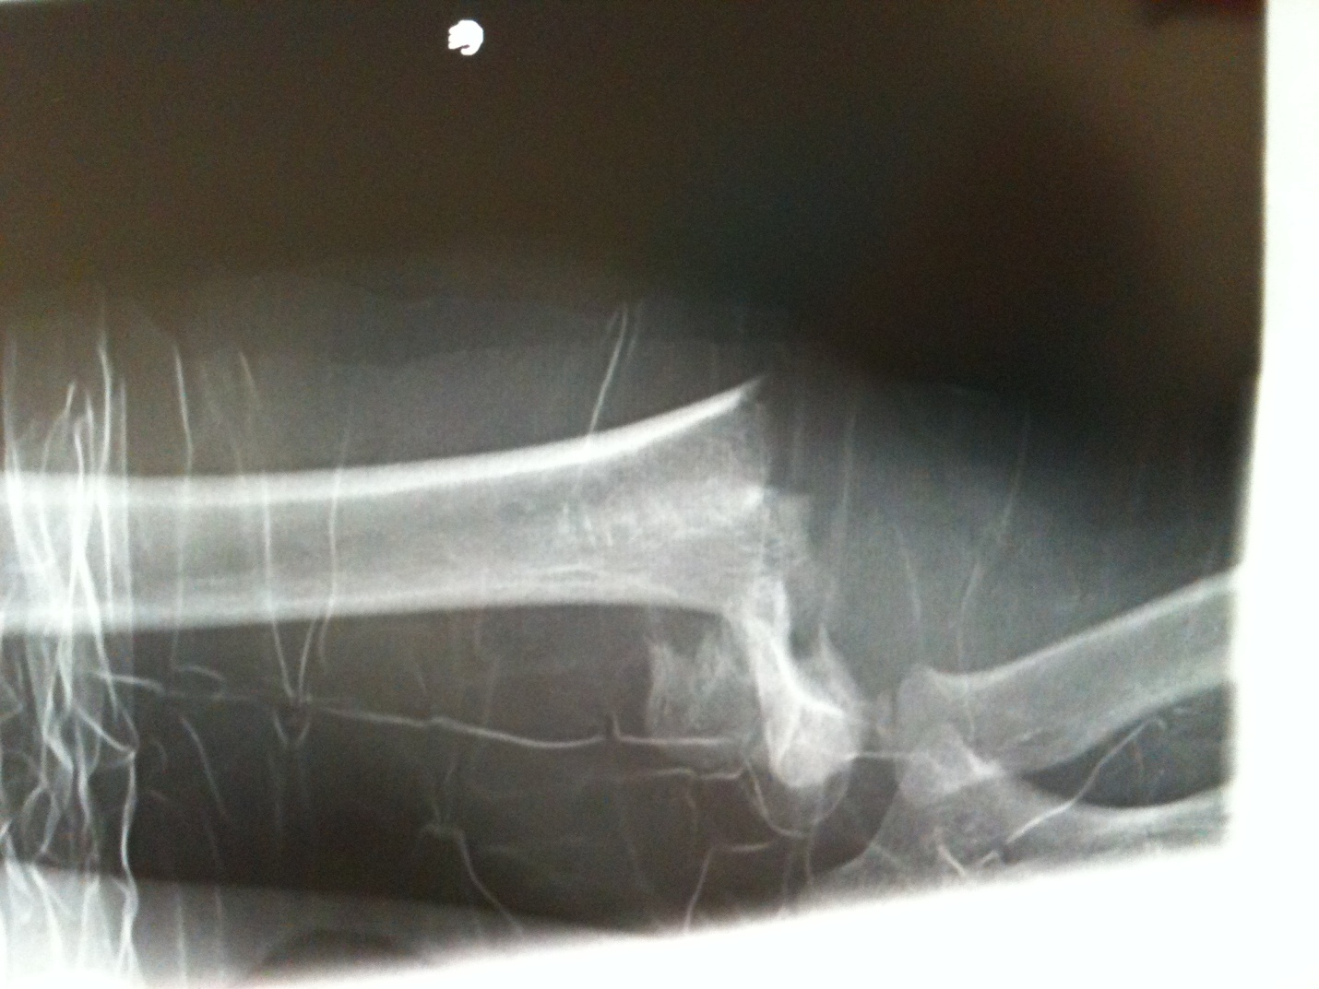

A 9 years old fell from climbing frame (5 marks).
- What is the diagnosis?
- What are the important points on physical examination?
- What nerve(s) might have damage in this diagnosis?
- What is the most common complication?
- What is the most important complication?

Question 2
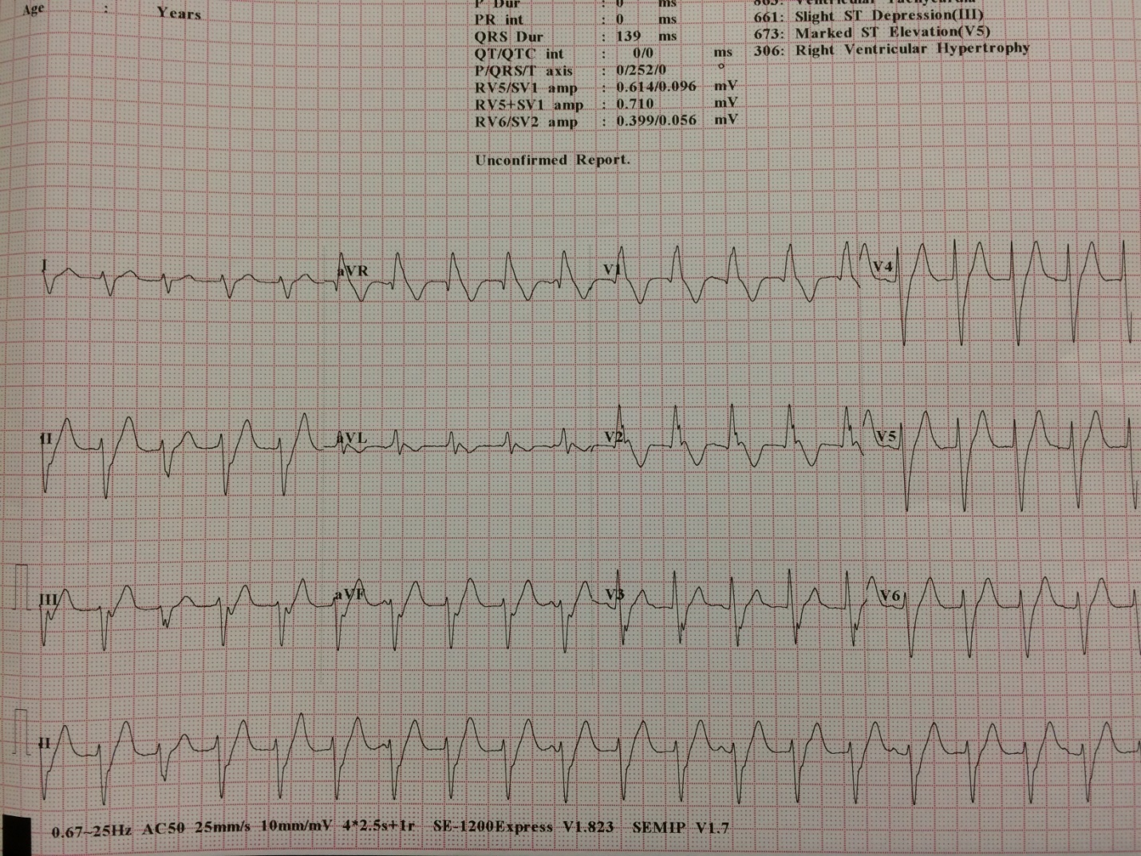

A 40 years old man complained palpitation for 1 hr.
- What are the ECG findings?
- What is the diagnosis?
- What is the most common form of this dysrrhymia?
- What is the first line treatment?
- What is the definitive treatment?

Question 3
A 59 years old man presented with headache and unsteady gait x 4 days, he had no history of head injury with GCS 12/15, equal & reactive pupils on physical examination.

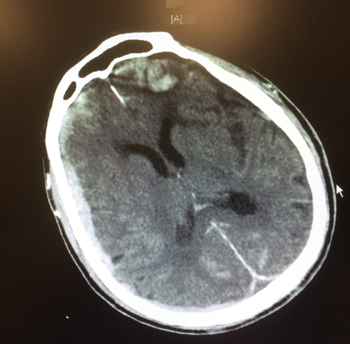
- What is the diagnosis?
- What other investigations to confirm the diagnosis?
- Apart from Hunt & Hess grading system, what is the other grading system?
- What I the name of scale to predict the likelihood of cerebral vasospasm?
- What are the common complications (3 marks)?

Question 4
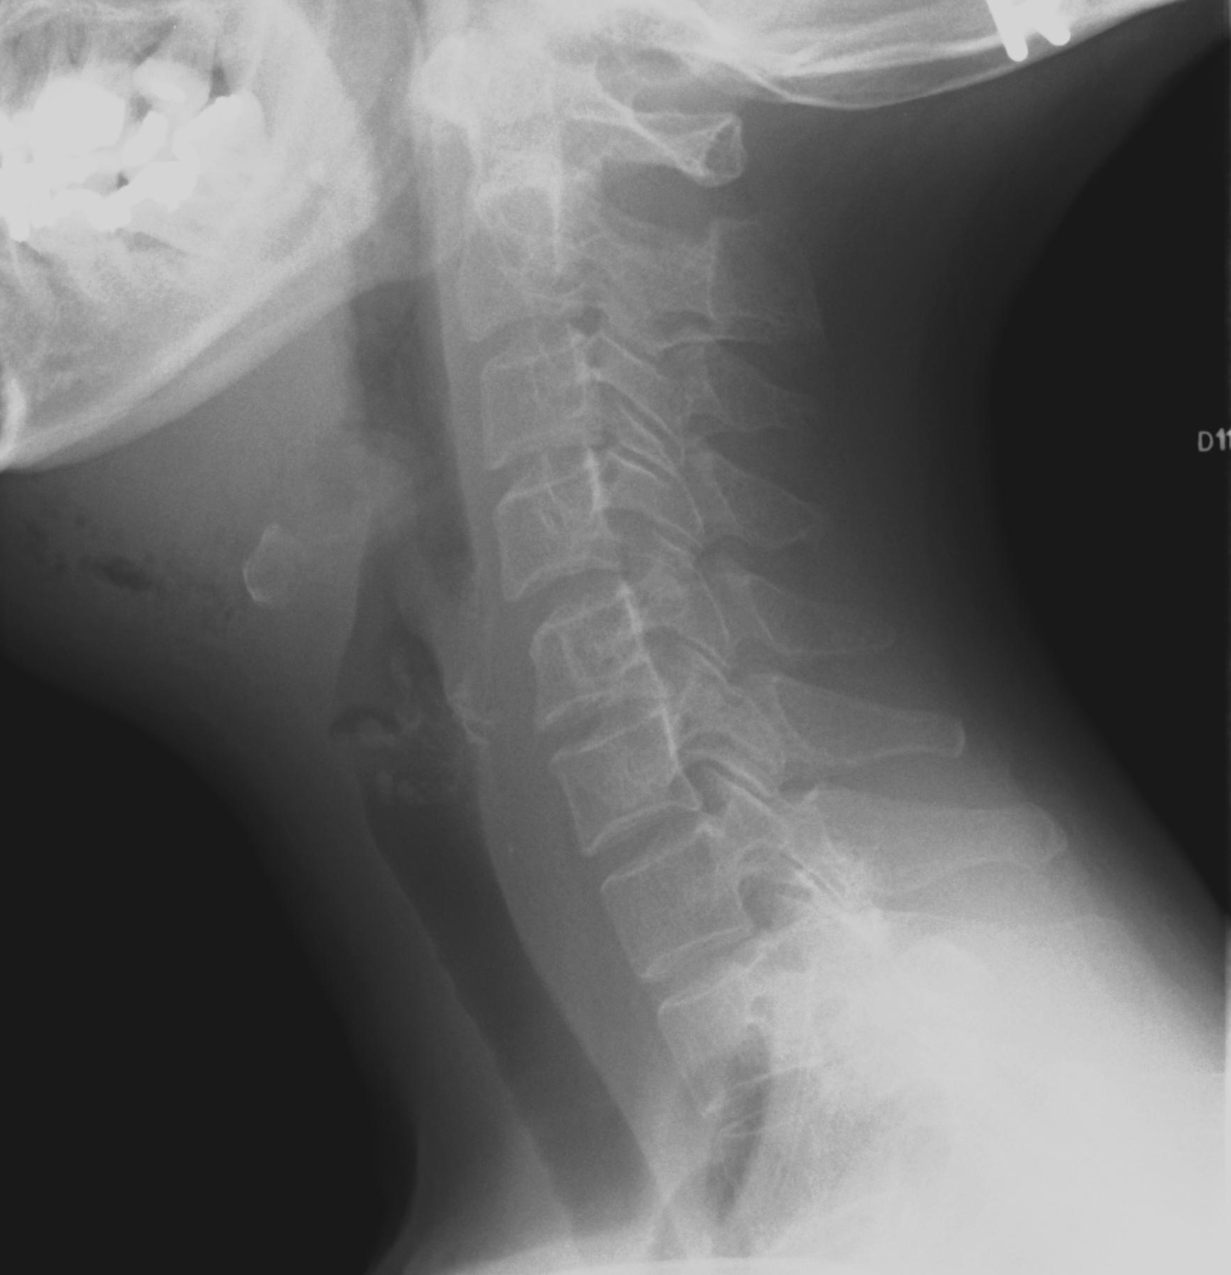

- What is the diagnosis?
- What are the symptoms and signs?
- What is the test useful in making the diagnosis?
- What are the most important points during treatment?

Question 5
A 3-year-old boy was found in distress while playing alone with toys. On arrival, he was cyanotic and respiratory rate was 8/min. Pulse was only palpable in carotid arteries. He was transferred to the resuscitation cubicle and the initially ECG rhythm strip showed sinus bradycardia of rate 50/min.
- How you manage this child? (4marks)
- Size of ET suggested
- What should you do if no intravenous access is established?
- Where will you insert the IO needle?
- What are the complications of IO procedure?

